Lecture 1.1.3 Cardinality and Power Set
Course outcome to be covered:
CO1: Apply and recognized about the theory of sets.

Finite and Infinite sets, Cardinality of sets, Classes of sets 1.1.3

Finite Sets and Infinite Sets
Finite sets and Infinite sets are totally different from each other. As the name suggests, the finite set is countable and contains a finite number of elements. The set which is not finite is known as the infinite set. The number of elements present in an infinite set is not finite and extends up to infinity. Please note that we can have countable infinite sets such as the set of rational numbers. We come across various finite sets and infinite sets in our daily lives.

What are Finite Sets?
Finite sets are sets having a finite or countable number of elements. It is also known as countable sets as the elements present in them can be counted. In the finite set, the process of counting elements comes to an end. Starting and ending elements are present in the set. Finite sets can be easily represented in roster notation form. For example, the set of vowels in English alphabets, Set A = {a, e, i, o, u} is a finite set as the number of elements of the set are finite.
Finite Sets are defined as sets with a finite number of elements. Elements of finite sets can be counted. Please note that all finite sets are countable but not all countable sets are finite.
For example, consider a set of even natural numbers less than 11, A = {2, 4, 6, 8, 10}. As we can see, set A has 5 elements which is a finite number and the elements can be counted.

What are Infinite Sets?
Infinite sets can be understood as sets that are not finite. The elements of infinite sets are endless, that is, infinite. If any set is endless from start or end or both sides having continuity then we can say that set is infinite. For example, the set of whole numbers, W = {0, 1, 2, 3, ……..} is an infinite set as the number of elements is infinite. The set of real numbers is an example of uncountable infinite sets. The elements of an infinite set are represented by dots as the dots represent the infinity of the set.
Infinite sets in set theory are defined as sets that are not finite. The number of elements in an infinite set goes to infinity, that is, we cannot determine the exact number of elements. Although we can have countably infinite sets whose elements can be counted.
For example, the set of integers, Z = {……… -2, -1, 0, 1, 2, ……….} is a countably infinite set as the number of elements in the set is infinite and its elements can be put in one-to-one correspondence with the set of natural numbers.

Difference Between Finite Sets and Infinite Sets
There are several similarities and differences between finite sets and infinite sets. Some of the common differences are summarized in the table below:

Finite Sets | Infinite Sets
All finite sets are countable. | Infinite sets can be countable or uncountable.
The union of two finite sets is finite. | The union of two infinite sets is infinite.
A subset of a finite set is finite. | A subset of an infinite set may be finite or infinite.
The power set of a finite set is finite. | The power set of an infinite is infinite.
Example: Set of even natural numbers less than 100, Set of names of months in a year | Example: Set of points on a line, Real numbers, etc.

Properties of Finite Sets
- A proper subset of a finite set is finite.
- The union of any number of finite sets is finite.
- The intersection of two finite sets is finite.
- The cartesian product of finite sets is finite.
- The cardinality of a finite set is a finite number and is equal to the number of elements in the set.
- The power set of a finite set is finite.

Properties of Infinite Sets
- The union of any number of infinite sets is an infinite set.
- The power set of an infinite set is infinite.
- The superset of an infinite set is also infinite.
- A subset of an infinite set may or may not be infinite.
- Infinite sets can be countable or uncountable. For example, the set of real numbers is uncountable whereas the set of integers is countable.
Important Notes on Finite Sets and Infinite Sets
- An empty set is a finite set with cardinality equal to zero.
- The cardinality of rational numbers is equal to the cardinality of natural numbers.
- All finite sets are countable whereas infinite sets may or may not be countable.

Cardinality of a Set
Cardinal numbers are counting numbers, so to find the cardinality of a set, the number of items in the set must be counted. This is a measurement of size or the number of elements within a specific set. The cardinality of a set is notated using the absolute value symbol. Here are some examples:
- X = { }, therefore lXl = 0
- W = {walrus}, therefore lWl = 1
- P = {numbers on a phone}, therefore lPl = 10
- C = {x: x > 30}, therefore lCl = {eq}∞ {/eq}

How to Find Cardinality of a Set
In order to determine the cardinality of a set, one must count the items in the set. A set can never contain a negative number of items. The cardinality will always be either zero, infinity, or a positive whole number. Here is one example that often confuses students:
- T = {-64, -973, -35, -554}, therefore lTl = 4.
Even though the items in the set are negative, the cardinality is the count of the number of items in a set and it will always be either 0 or positive. There are four negative numbers so there are exactly four elements in this set.
Equal sets are sets with the exact same elements.
Let two sets K = {4, 3, 6, 1} and V = {1, 3, 4, 6}.
K = V
Even though the elements are in a different order, they are the same elements. These sets are equal.
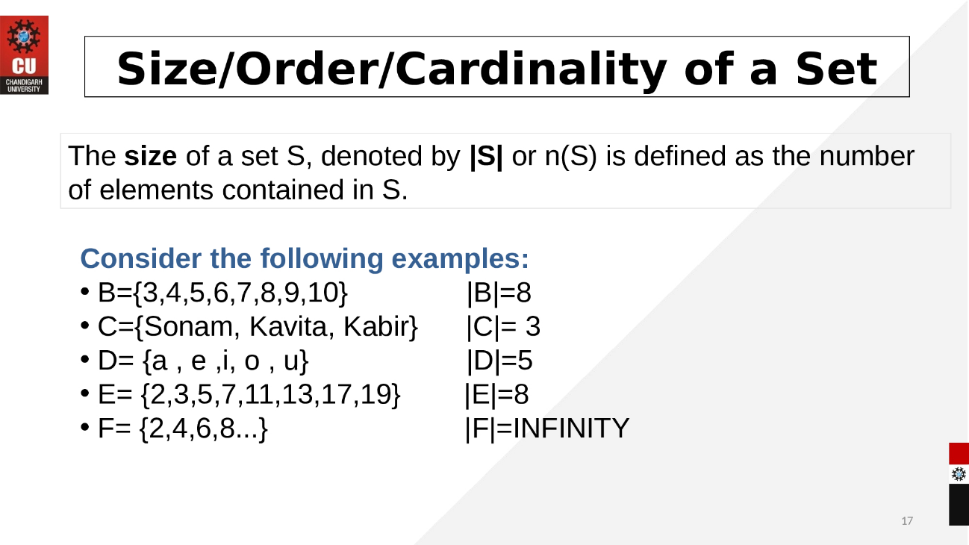

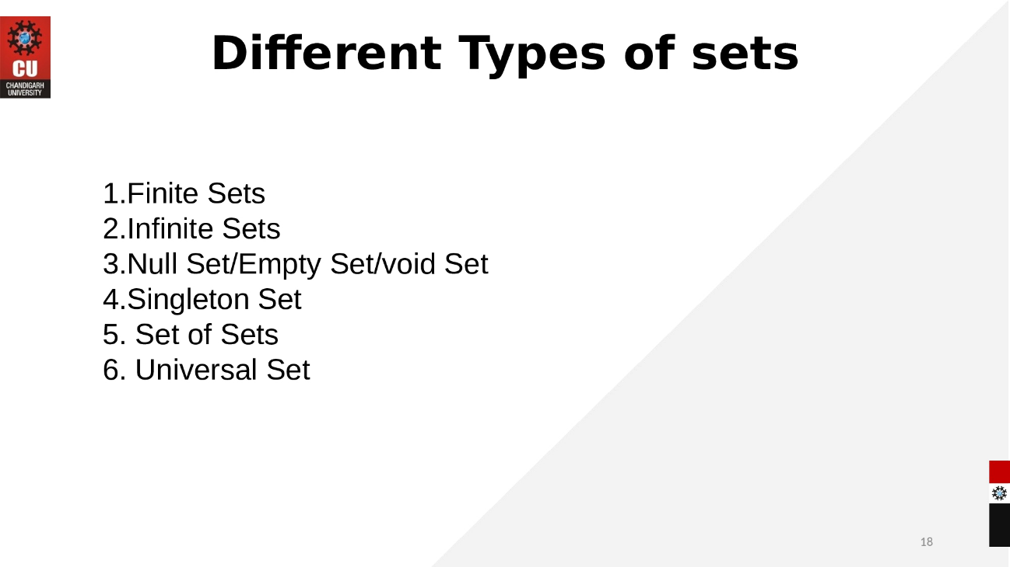
eBook Discrete Mathematics
https://vcarrion.people.uic.edu/Pinter%20-%20A%20Book%20of%20Set%20Theory.pdf

LINKS: https://youtu.be/Zz7KGsFJkPo

